

# 

### Semester Two Examination, 2019

### Question/Answer booklet

# MATHEMATICS

**APPLICATIONS**

**UNITS 1 AND 2**

## Section Two:

## Calculator-assumed

Your name

## Teacher name (please circle) Hennighan Hill Scorer Toh

## Time allowed for this section

Reading time before commencing work: ten minutes

Working time: one hundred minutes

## Materials required/recommended for this section

***To be provided by the supervisor***

This Question/Answer booklet

Formula sheet (retained from Section One)

***To be provided by the candidate***

Standard items: pens (blue/black preferred), pencils (including coloured), sharpener,  
correction fluid/tape, eraser, ruler, highlighters

Special items: drawing instruments, templates, notes on two unfolded sheets of A4 paper, and up to three calculators approved for use in this examination

## Important note to candidates

No other items may be taken into the examination room. It is **your** responsibility to ensure that you do not have any unauthorised material. If you have any unauthorised material with you, hand it to the supervisor **before** reading any further.

## Structure of this paper

|  |  |  |  |  |  |
| --- | --- | --- | --- | --- | --- |
| Section | Number of questions available | Number of questions to be answered | Working  time (minutes) | Marks available | Percentage of examination |
| Section One:  Calculator-free | 8 | 8 | 50 | 52 | 35 |
| Section Two:  Calculator-assumed | 13 | 13 | 100 | 98 | 65 |
|  | | |  | **Total** | 100 |

|  |  |  |
| --- | --- | --- |
| Markers use only | | |
| Question | Maximum | Mark |
| 9 | 6 |  |
| 10 | 6 |  |
| 11 | 7 |  |
| 12 | 11 |  |
| 13 | 7 |  |
| 14 | 8 |  |
| 15 | 8 |  |
| 16 | 7 |  |
| 17 | 8 |  |
| 18 | 9 |  |
| 19 | 6 |  |
| 20 | 7 |  |
| 21 | 8 |  |
| S2 Total | 98 |  |
| S2 Wt (×0.6633) | 65% |  |

## Instructions to candidates

1. The rules for the conduct of examinations are detailed in the school handbook. Sitting this examination implies that you agree to abide by these rules.

2. Write your answers in this Question/Answer booklet preferably using a blue/black pen.  
Do not use erasable or gel pens.

3. You must be careful to confine your answer to the specific question asked and to follow any instructions that are specified to a particular question.

4. Show all your working clearly. Your working should be in sufficient detail to allow your answers to be checked readily and for marks to be awarded for reasoning. Incorrect answers given without supporting reasoning cannot be allocated any marks. For any question or part question worth more than two marks, valid working or justification is required to receive full marks. If you repeat any question, ensure that you cancel the answer you do not wish to have marked.

5. It is recommended that you do not use pencil, except in diagrams.

6. Supplementary pages for planning/continuing your answers to questions are provided at the end of this Question/Answer booklet. If you use these pages to continue an answer, indicate at the original answer where the answer is continued, i.e. give the page number.

7. The Formula sheet is not to be handed in with your Question/Answer booklet.

Section Two: Calculator-assumed 65% (98 Marks)

This section has**thirteen (****13)** questions. Answer **all** questions. Write your answers in the spaces provided.

Working time: 100 minutes.

Question 9 (6 marks)

A person who moved to Australia exchanged $80 000$ euros for Australian dollars and placed the proceeds into a $3$-month term deposit.

At the time of the exchange, $1$ euro bought $1.6067$ Australian dollars.

(a) Determine the amount the person deposited in the term deposit. (1 mark)

(b) The term deposit paid simple interest of $1.5\%$ per annum. Calculate the interest earned in the deposit over the $3$ months. (2 marks)

(c) After another currency exchange, the person placed $\$75 000$ into a savings account paying $2.6\%$ interest compounded monthly. Determine the interest that accumulated in this account during the first $6$ months. (3 marks)

Question 10 (6 marks)

Determine, with justification, the area of each of the following triangles.

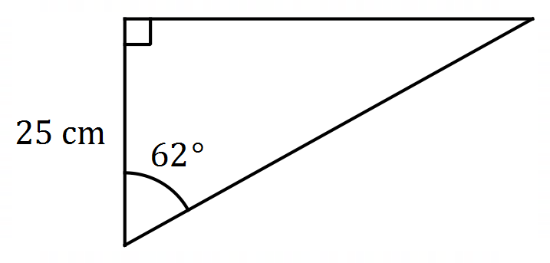(a) (2 marks)

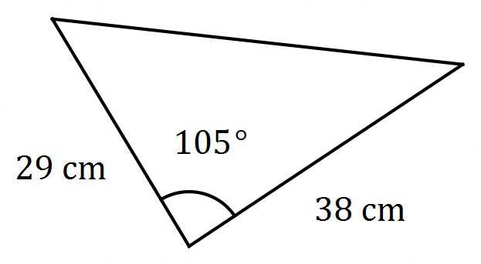

(b) (2 marks)

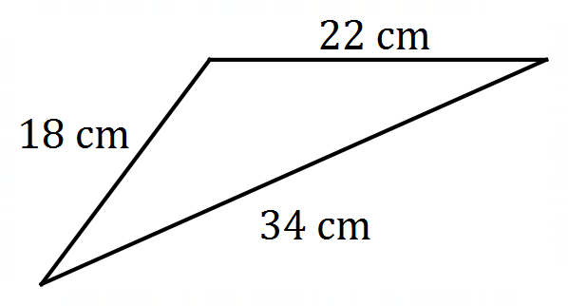(c) (2 marks)

Question 11 (7 marks)

A survey of the ages, $x$, of $300$ football fans at a recent match gave rise to the following data.

|  |  |
| --- | --- |
| Age group | Frequency |
| $$18≤x<30$$ | $$54$$ |
| $$30≤x<40$$ | $$60$$ |
| $$40≤x<50$$ | $$63$$ |
| $$50≤x<60$$ | $$75$$ |
| $$60≤x<80$$ | $$48$$ |

(a) Explain why it is necessary to use the interval midpoint of each age group when calculating the mean age of the fans. (1 mark)

(b) State the interval midpoint for the age group $60≤x<80$. (1 mark)

(c) Determine the mean and standard deviation of the ages of the fans in the survey, rounding your values to $2$ decimal places. (3 marks)

It was later discovered that of the $48$ fans aged $60$ or more, one was aged $75$ and all the others were younger than $64$.

(d) Use this information to determine better estimates for the mean and standard deviation of the ages of the fans in the survey. (2 marks)

Question 12 (11 marks)

Every month a small business runs $15$ information seminars for prospective customers. The number of people attending the seminars in two consecutive months is summarised below, where the largest turnout for a June seminar was $82$ people.

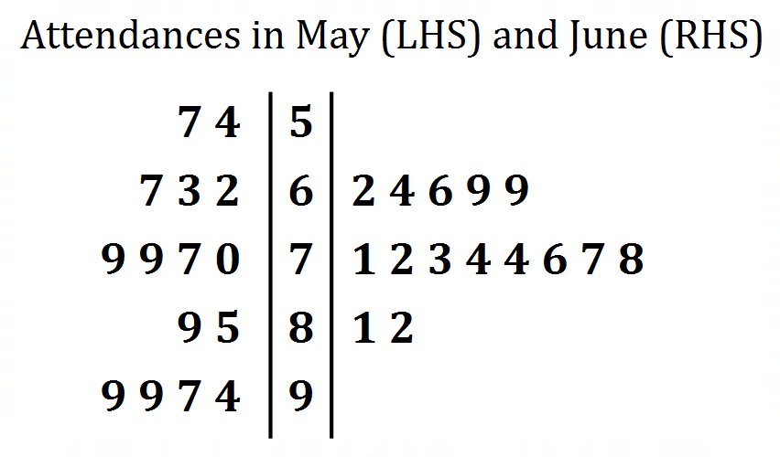**Key: 8|1 = 81**

(a) Determine the range of attendance figures for May. (2 marks)

(b) Construct parallel boxplots for the May and the June attendances on the grid below.

(6 marks)

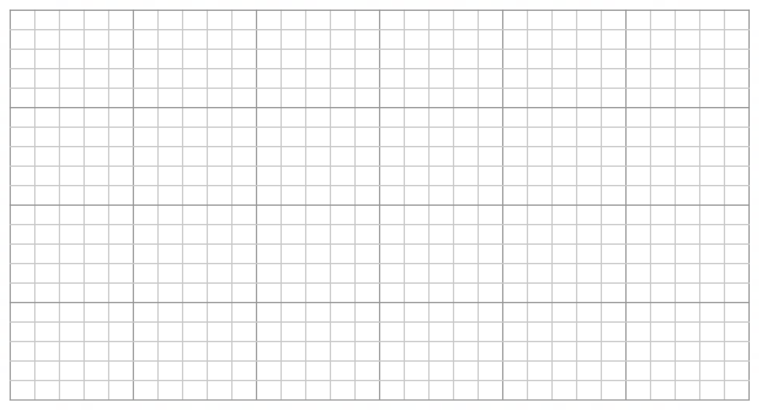

(c) Compare the attendance figures for May with those of June. (3 marks)

Question 13 (7 marks)

A field is bounded by four straight fences $PQ, QR,RS$ and $SP$ as shown below, where $QR=120$ m, $RS=160$ m, $SP=290$ m and $∠PQS=∠QRS=90°$.

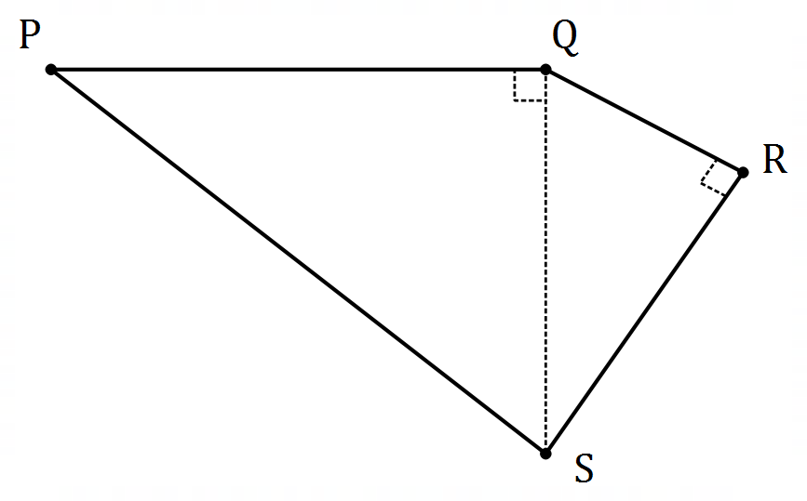

(a) Determine the distance $QS$. (1 mark)

(b) The fence around the field needs maintenance at a cost of $\$1.15$ per metre. Determine the cost of this maintenance. (3 marks)

(c) The field was recently sprayed with a treatment at a total cost of $\$382.50$. Calculate the cost, in cents per square metre, of this treatment. (3 marks)

Question 14 (8 marks)

A person is considering a choice of two caterers to supply snacks for an office party. Caterer $A$ charges $\$20$ per person plus a once-off booking fee of $\$150$.

(a) Calculate the cost of using caterer $A$ when

(i) $10$ people are expected to attend. (1 mark)

(ii) $40$ people are expected to attend. (1 mark)

(b) Plot the two catering costs from (a) on the axes below and draw a straight line through them. (2 marks)

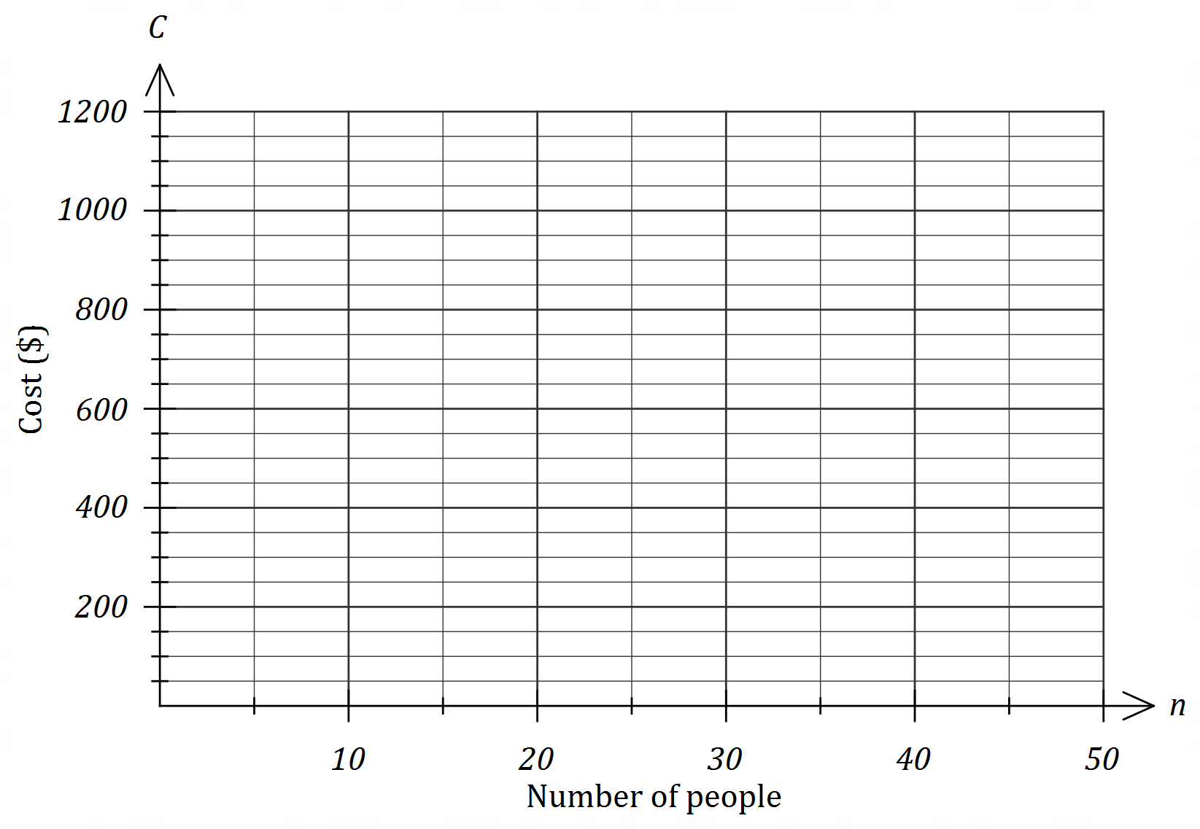

Caterer $B$ simply charges $\$25$ per person.

(c) Add a line to the graph above to represent the cost of using caterer $B$. (2 marks)

(d) Write a brief statement to the person recommending which caterer to use if minimising the cost was the only consideration. (2 marks)

Question 15 (8 marks)

The shaded areas in the diagram below form a logo for a business. $OABCD$ is a semicircle with radius $OA=30$ cm and $∠AOB=∠BOC=∠COD$. The inner semicircle has radius $OE=14$ cm.

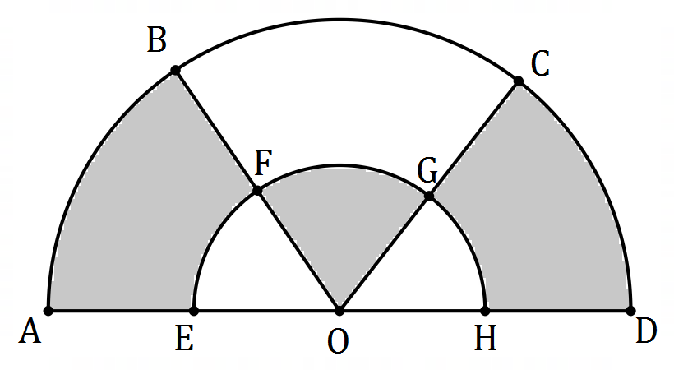

(a) Determine the area of the sector $OFG$. (2 marks)

(b) Determine the total shaded area. (3 marks)

(c) Determine the shaded area in a copy of the logo that is enlarged by a scale factor of $5$ for use on a flag, giving your answer in square metres. (3 marks)

Question 16 (7 marks)

The lifetimes of a type of heating element are normally distributed with a mean of $455$ hours and a standard deviation of $32$ hours.

(a) State the percentage of elements that are expected to have a lifetime within two standard deviations of the mean. (1 mark)

(b) Determine the standard score for an element that lasts for $433$ hours. (2 marks)

(c) Determine the probability that a randomly selected element will have a lifetime

(i) of less than $433$ hours. (1 mark)

(ii) of more than $510$ hours. (1 mark)

(iii) within $25$ hours of the mean lifetime. (2 marks)

Question 17 (8 marks)

Three small huts lie on level ground. Hut $B$ lies $450$ m due north of hut $A$ and hut $C$ lies $570$ m from hut $A$ on a bearing of $125°$.

(a) Sketch a diagram to show this information. (2 marks)

(b) The huts are equipped with radios that have a range of $800$ m. Showing use of trigonometry, determine whether huts $B$ and $C$ can communicate by radio. (3 marks)

(c) Showing use of trigonometry, determine the bearing of hut $C$ from hut $B$. (3 marks)

Question 18 (9 marks)

A shop usually sells the same brand of AAA batteries in packs of $4$, $8$ and $14$ for $\$7.95, \$13.90$ and $\$19.92$ respectively, but currently has the $4$-packs and $8$-packs on sale at $20\%$ off.

(a) Determine the total price and hence the average price per battery for $18$ batteries when a customer buys a $4$-pack and a $14$-pack in the sale. (3 marks)

(b) Use the sale prices to rank the pack sizes in order of value from best to worst. (3 marks)

(c) The shop buys a carton containing $36$ of the $14$-packs from a wholesaler for $\$420.48$ excluding GST. The shop then adds their profit margin of $k\%$ and another $10\%$ GST to arrive at the advertised pack price above. Determine the value of $k$. (3 marks)

Question 19 (6 marks)

Entry fees at a mini-golf course for children, adults and seniors are $\$6.50, \$12.00$ and $\$7.25$ respectively. The following table shows the breakdown of the number of paying customers at the course over three days.

|  |  |  |  |
| --- | --- | --- | --- |
| Day | Children | Adults | Seniors |
| Friday | $$12$$ | $$63$$ | $$51$$ |
| Saturday | $$35$$ | $$82$$ | $$27$$ |
| Sunday | $$42$$ | $$75$$ | $$33$$ |

(a) Use two matrices to write a calculation that will result in matrix $M$, where $M$ shows the total entry fees collected on each of the three days and determine $M$. (3 marks)

(b) Matrix $M$ can be multiplied by matrix $N$ to produce a $1×1$ matrix that shows the sum of all entry fees collected over the three days. Write down $N$. (1 mark)

(c) Use two matrices to write a calculation that will result in matrix $P$, where $P$ shows the total number of patrons in each fee category over the three days and determine $P$. (2 marks)

Question 20 (7 marks)

Employees at a car yard can opt to have their gross wage calculated in one of two ways:

* Option A - commission of $1.6\%$ of their weekly sales.
* Option B - commission of $1.1\%$ of their weekly sales plus $\$350$ per week.

(a) Determine the gross weekly wage for an employee choosing

(i) option A in a week when their sales were $\$125 500$. (1 mark)

(ii) option B in a week when their sales were $\$78 250$. (1 mark)

(b) The gross weekly wage for an employee using option B was $\$812$. Determine the weekly sales this employee made. (2 marks)

(c) Based on an employee's weekly sales, explain which option is best. (3 marks)

Question 21 (8 marks)

A solid monument built on level ground has the form of a pyramid mounted on a cubical base with sides of length $4.8$ m as shown below (not to scale). The vertex of the pyramid is $4.5$ m directly above the centre of its square base.

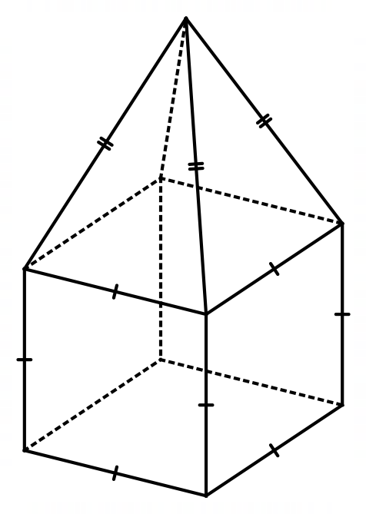

(a) Determine the volume of the monument, to the nearest cubic metre. (3 marks)

(b) Determine the total surface area of the monument, excluding its square base that rests on the ground. (5 marks)

Supplementary page

Question number: _________

Supplementary page

Question number: _________

Supplementary page

Question number: _________

© 2019 WA Exam Papers. Kennedy Baptist College has a non-exclusive licence to copy and communicate this document for non-commercial, educational use within the school. No other copying, communication or use is permitted without the express written permission of WA Exam Papers. SN245-143-3.